## Monteverde, Costa Rica

1. 
2. 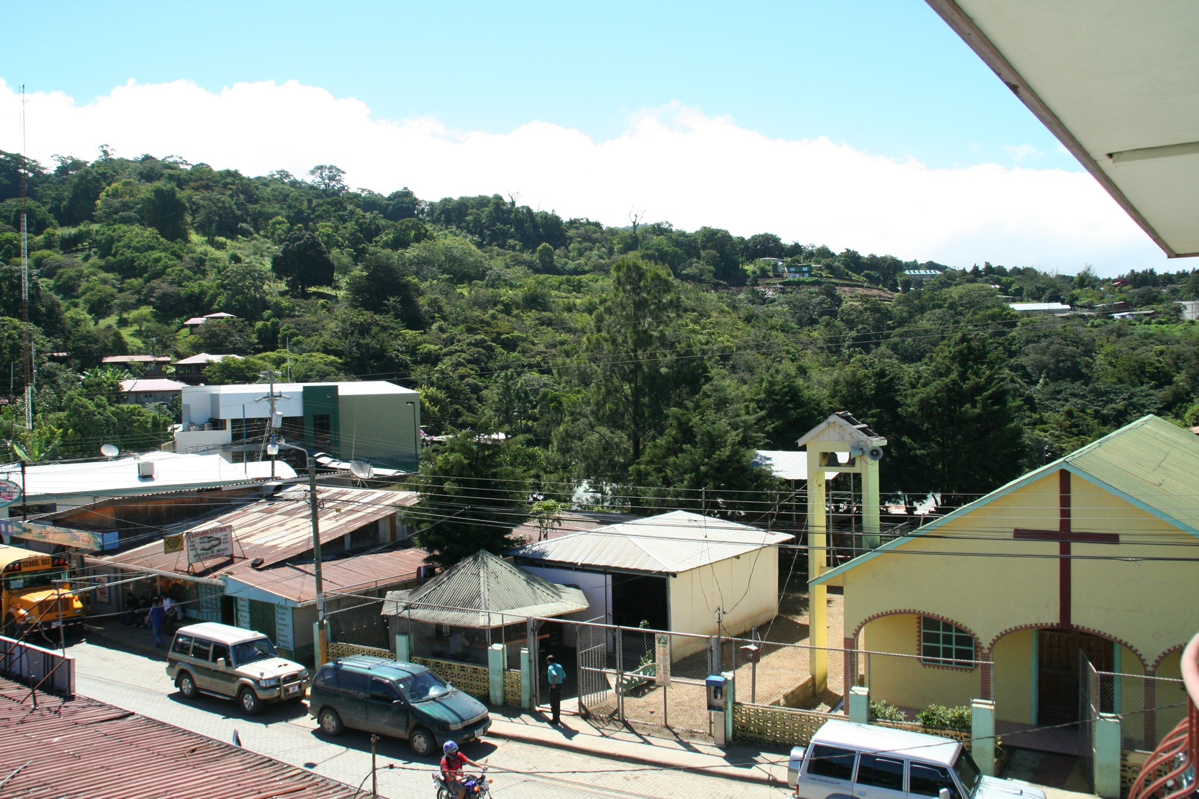
3. Monteverde.gif
4. Monteverde_skyline.jpeg
5. **Geographical Location**: South America
6. Monteverde, Costa Rica is situated 4,662 feet above sea level. Monteverde’s famed cloud forests are the byproduct of fog (a thick, low-hanging cloud) tangling amongst the leaves and branches of the forest canopy. Trails and hanging bridges offer a close-up view of the diverse variety of animals and plants living in the forest.
7. One of the main tourist locations in Monteverde is the town of Santa Elena, which is not only home to a variety of restaurants with delicious food, but a serpentarium as well. You can enjoy hiking, ziplining, and observing the native wildlife while staying in Monteverde. It’s a truly beautiful place.
8. **Photo Gallery**
9. Monteverde_cloud_forest.jpeg
10. Clouds rolling through a line of trees.
11. You can hike trails and zipline through the Monteverde cloud forests.
12. Monteverde_hanging_bridges.jpeg
13. An image of a bridge hanging above the cloud forest canopy in Monteverde.
14. Hanging bridges over the cloud forests allow for a birds-eye view.
15. Monteverde_hummingbirds.jpeg
16. A hummingbird with green feathers drinking from a pink and orange flower.
17. You can visit hummingbirds at Monteverde’s Selvatura Park’s hummingbird garden, which exhibits over 14 different species of hummingbird.
18. Monteverde_el_tigre_waterfalls.jpeg
19. A person in red standing in front of one of El Tigre’s four waterfalls.
20. El Tigre Waterfalls is made up of four falls, which are connected by trails and hanging bridges.
21. Kay Malan